**Robotic Process Automation to Unleash a Modern RPA Career**

Business leaders:

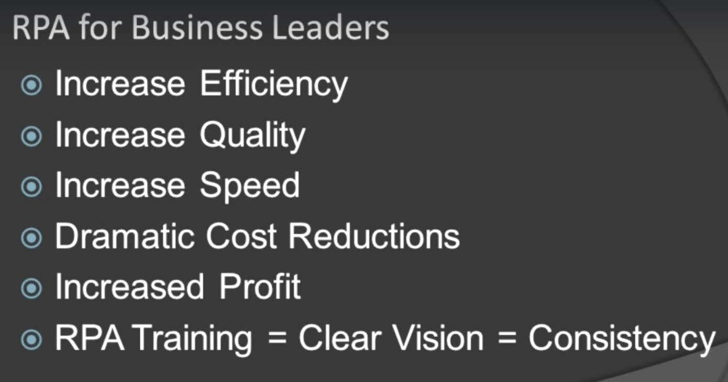

Employee:

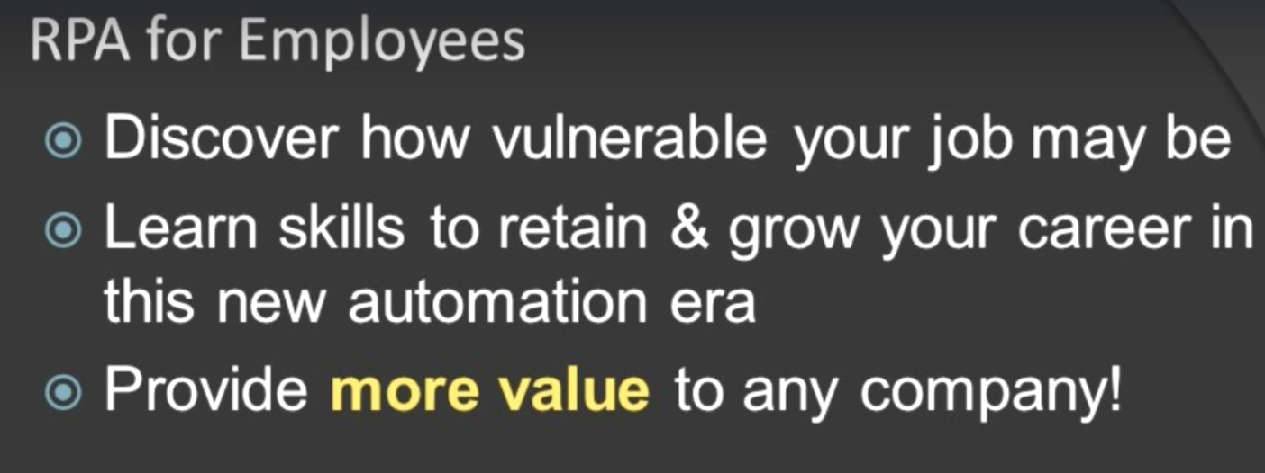

* What is RPA?

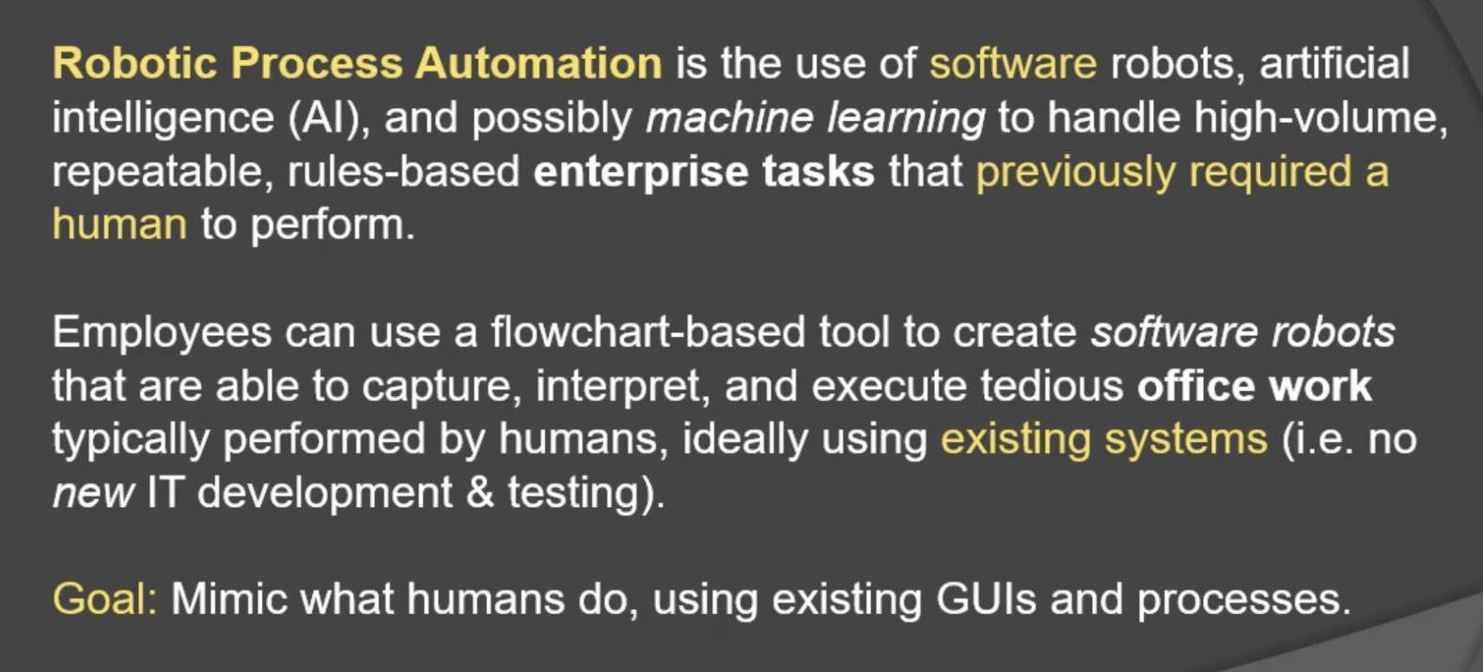

→ ideally using existing systems (a bot can be built within 1-2 months)

Goal is about mimicking the human processes

* Types of software bots: unattended & attended

Typical uses:

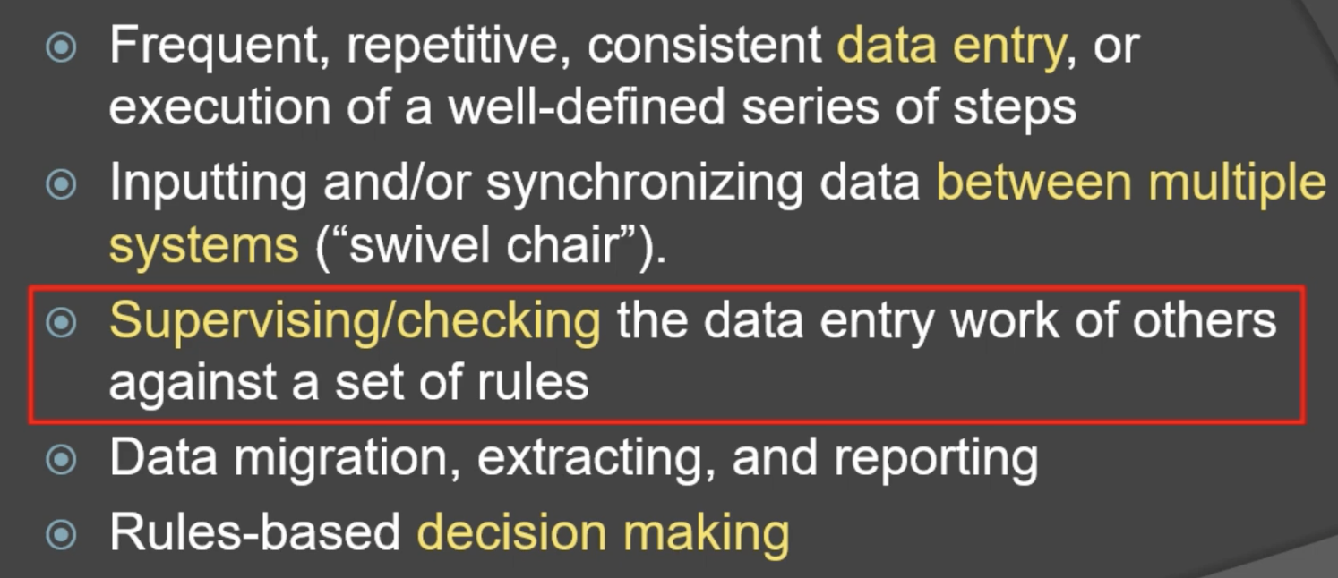

* Who is using RPAs?

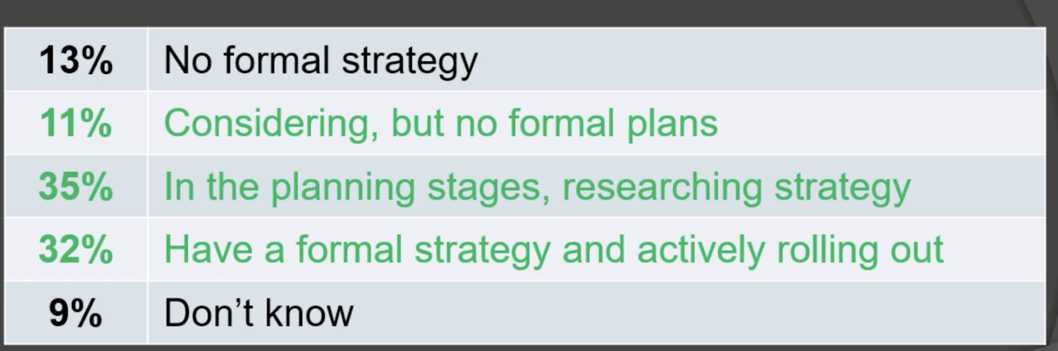

~78% is on their way of using RPAs

* Benefits for business:

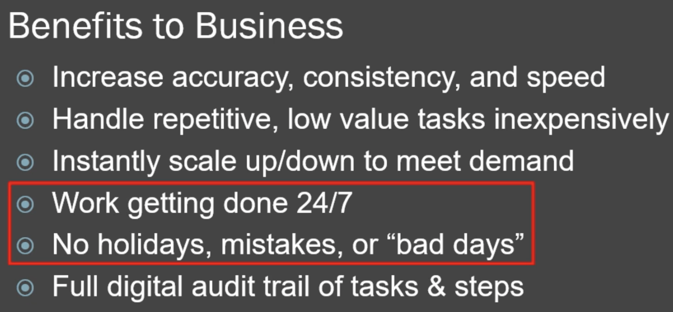

* Benefits to employees

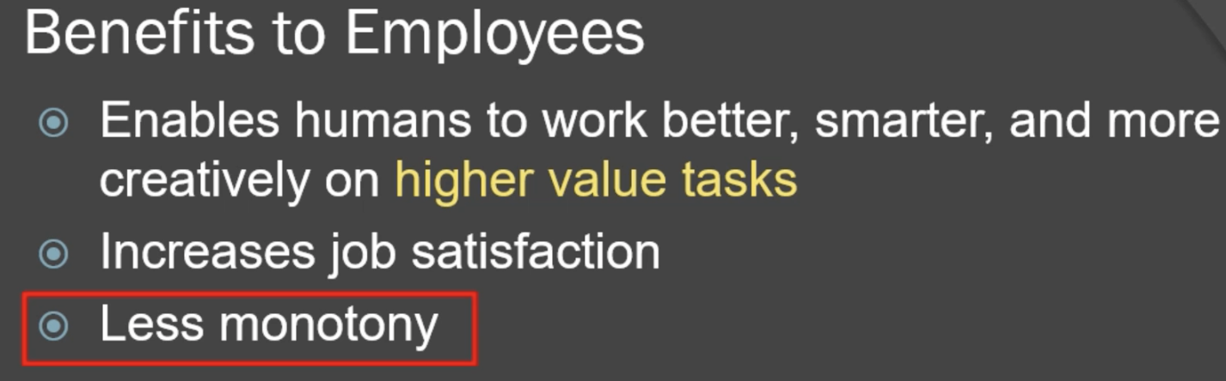

* What is RPA is not ?

RPA = digital workforce

* RPA vs. test automation

Regression testing: re-testing existing features of an application to ensure new changes didn’t break them.

For a given company, testing is only in engineering teams, but automation is about all departments.

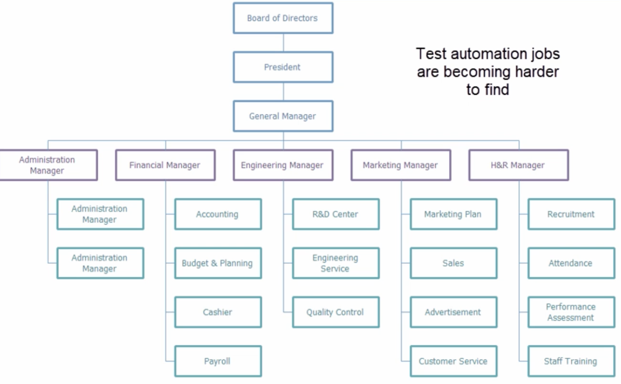

* How to build a simple software robot?

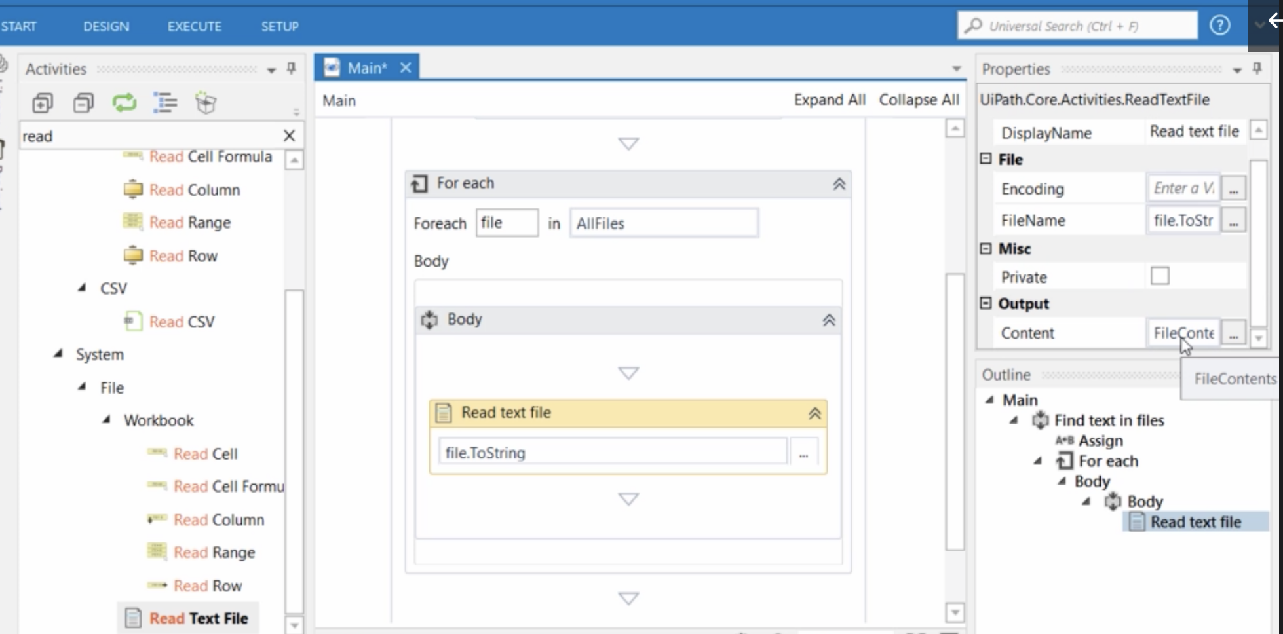

* History and drivers

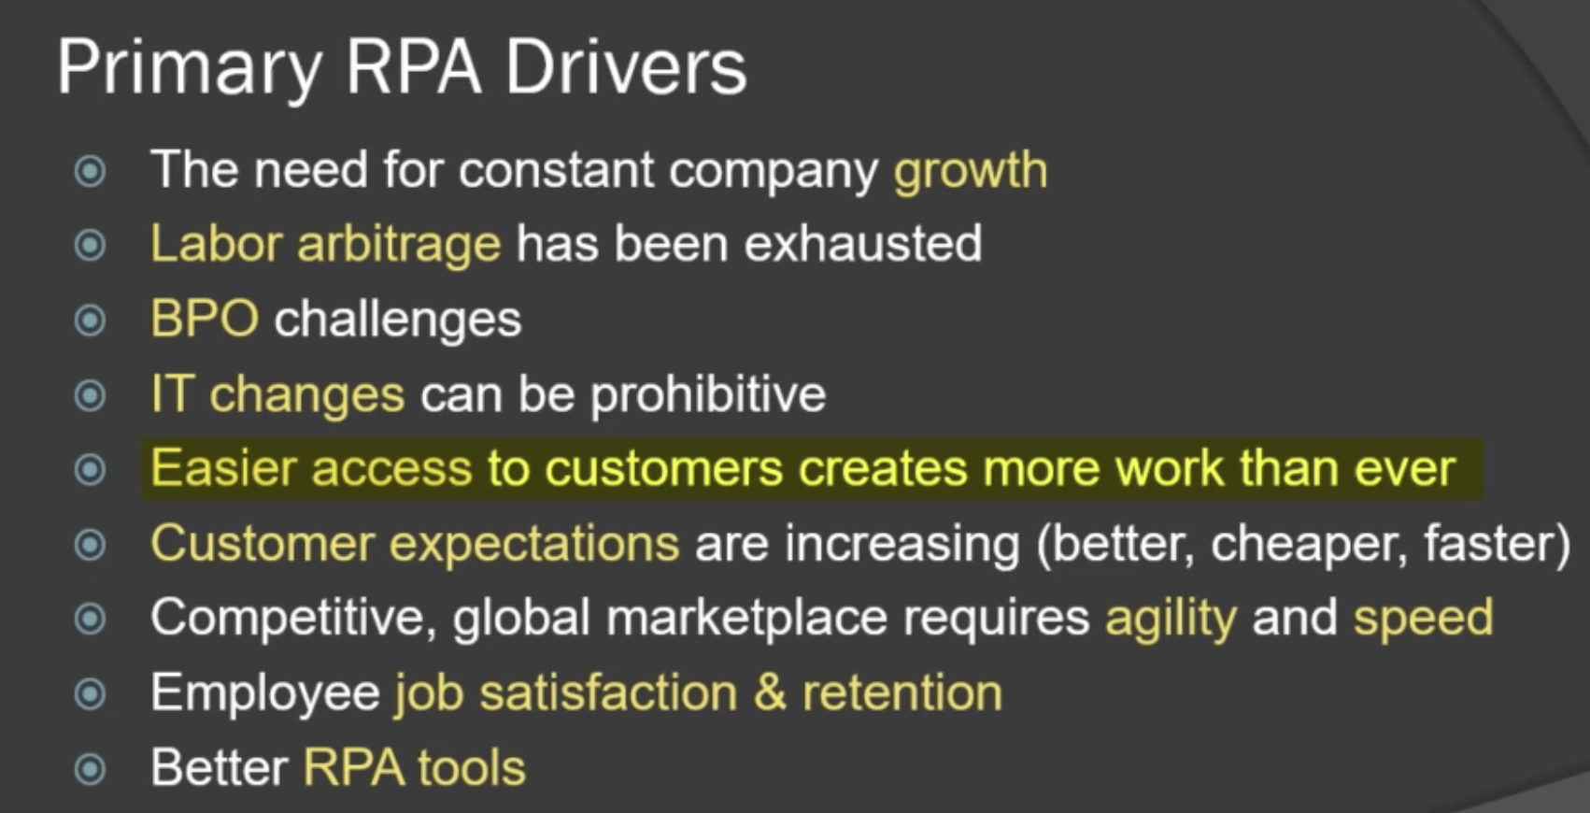

Labor arbitrage: (1) workers easily move to developed countries, (2) h1b, and (3) outsourcing

→ all the low was countries are used up

BPO: business process outsourcing

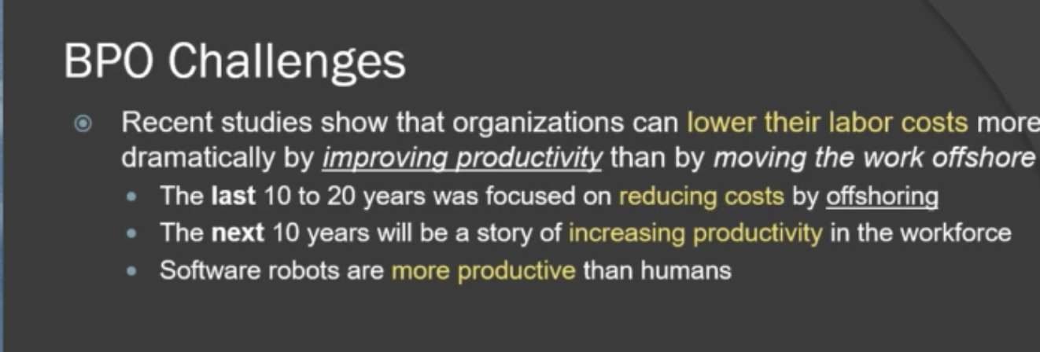

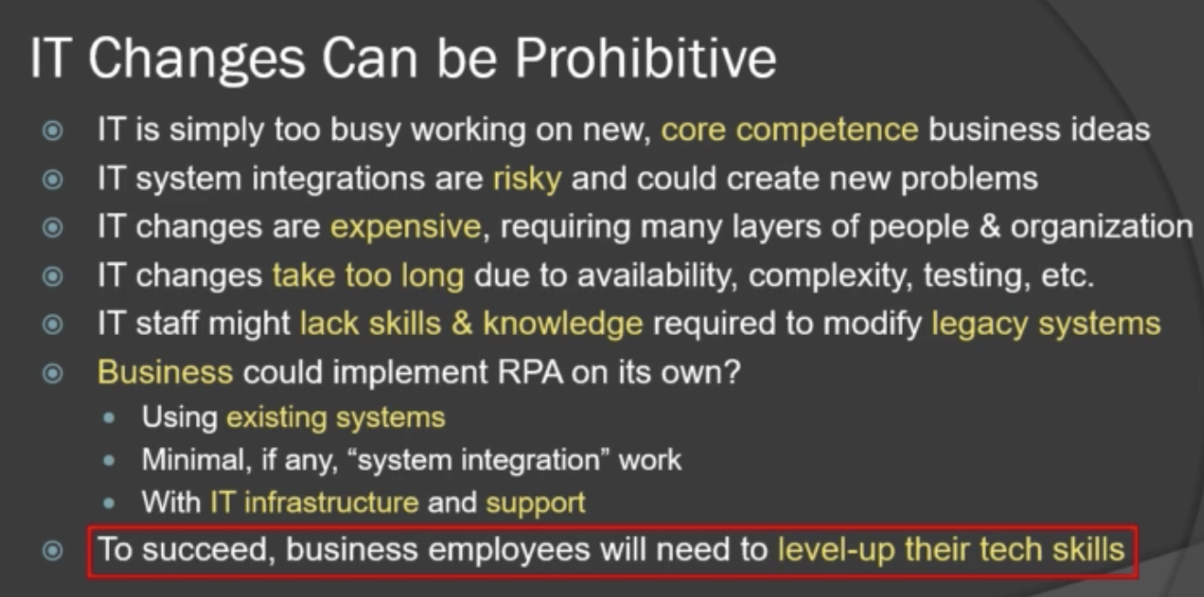

* Will RPA will outsourcing
* Best fit industries and functions

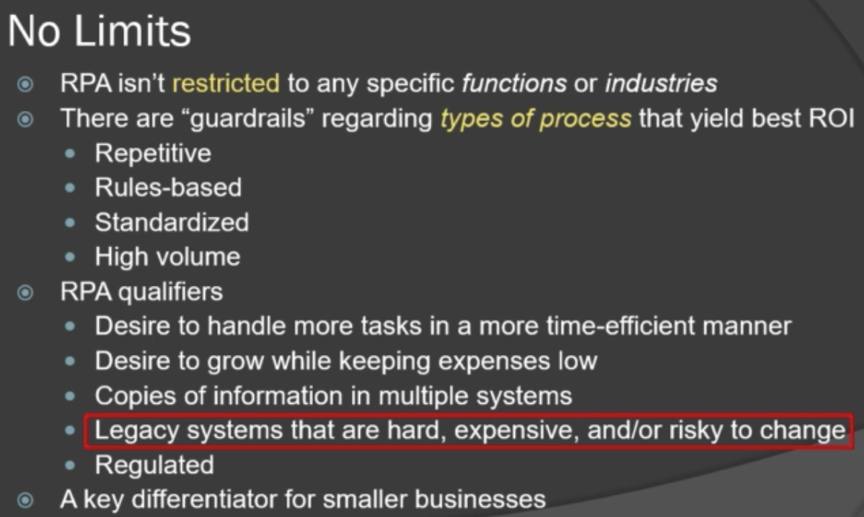

Adoption of RPAs: usually repetitive and rule-based processes

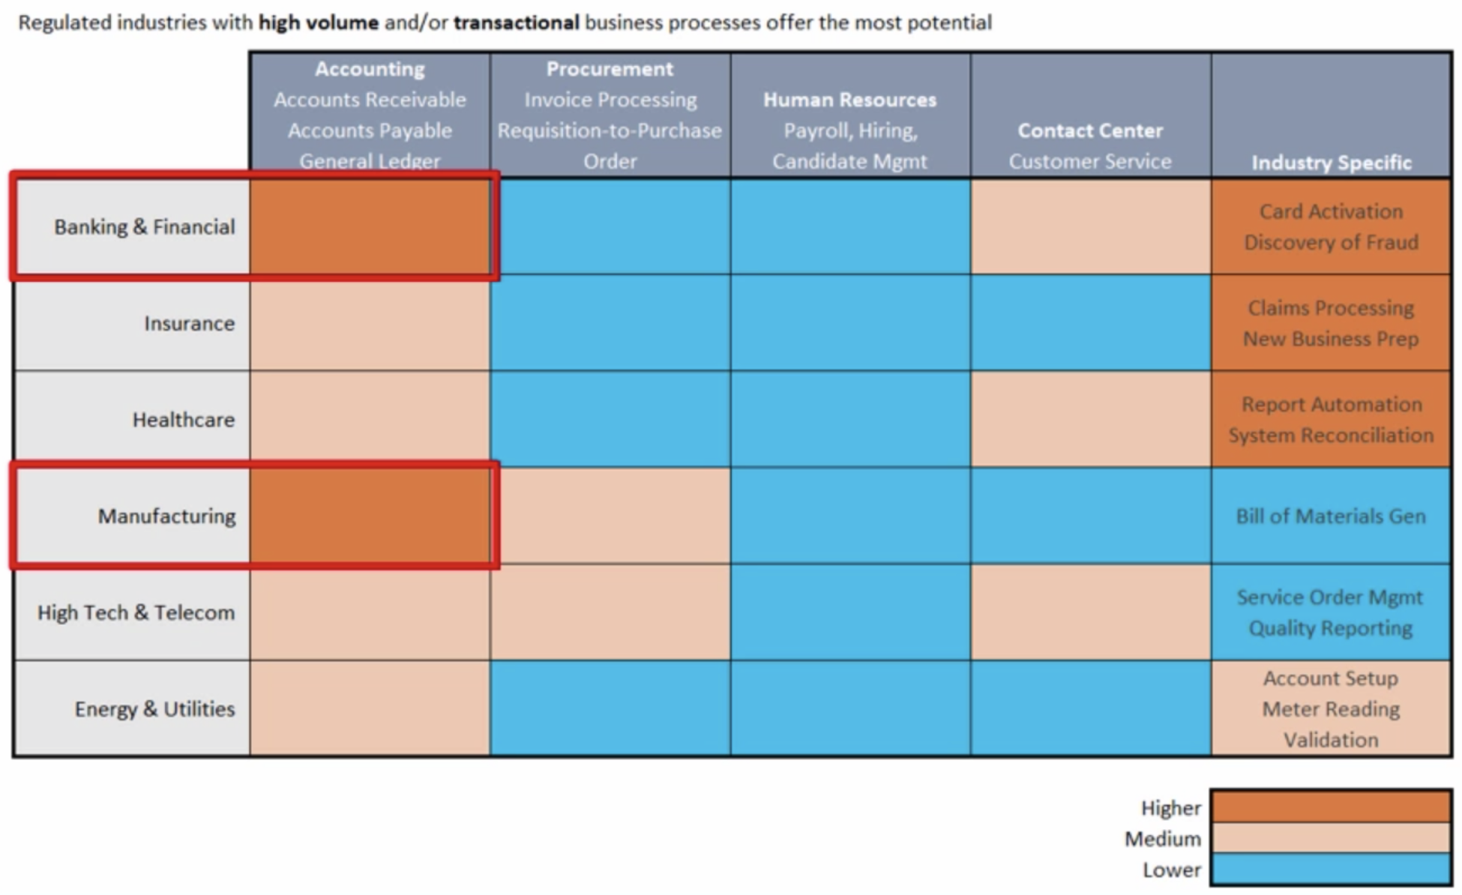

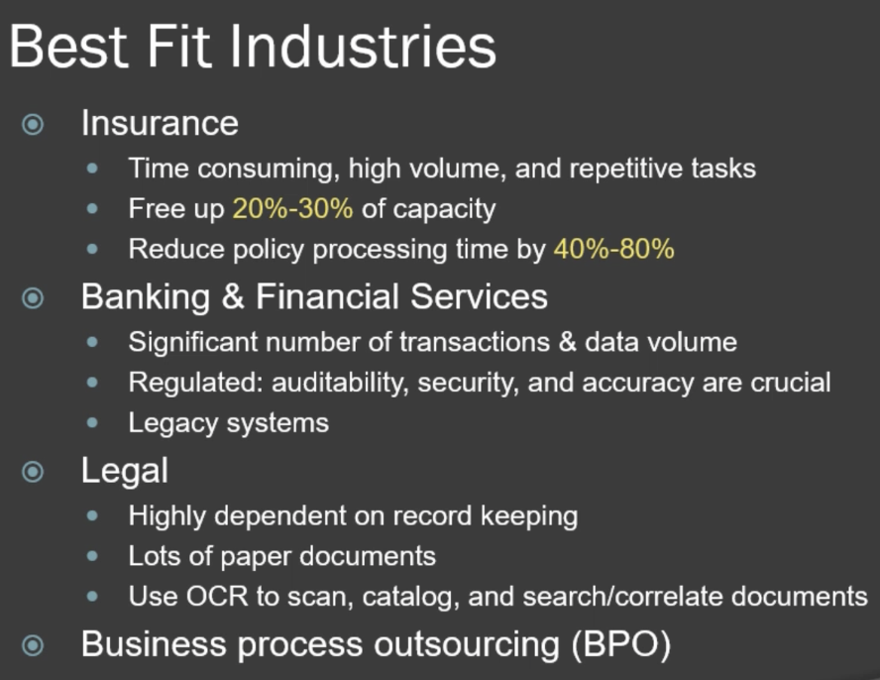

* Benefits, challenges, and risks of RPAs

Benefits:

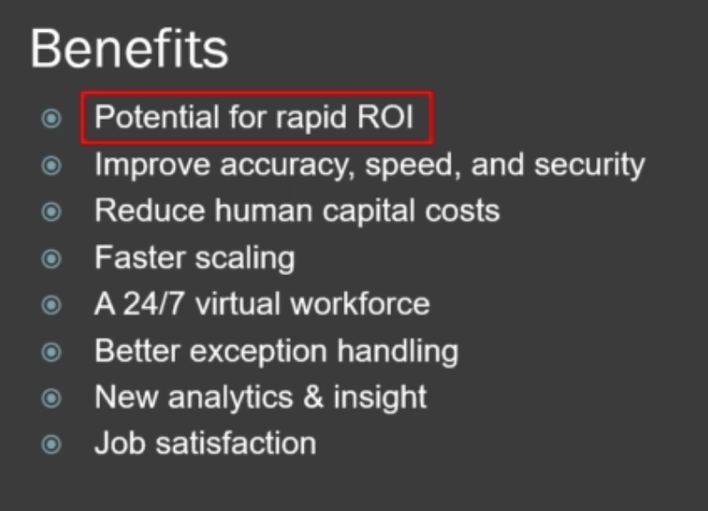

2-5: decrease costs and increase values

Challenges: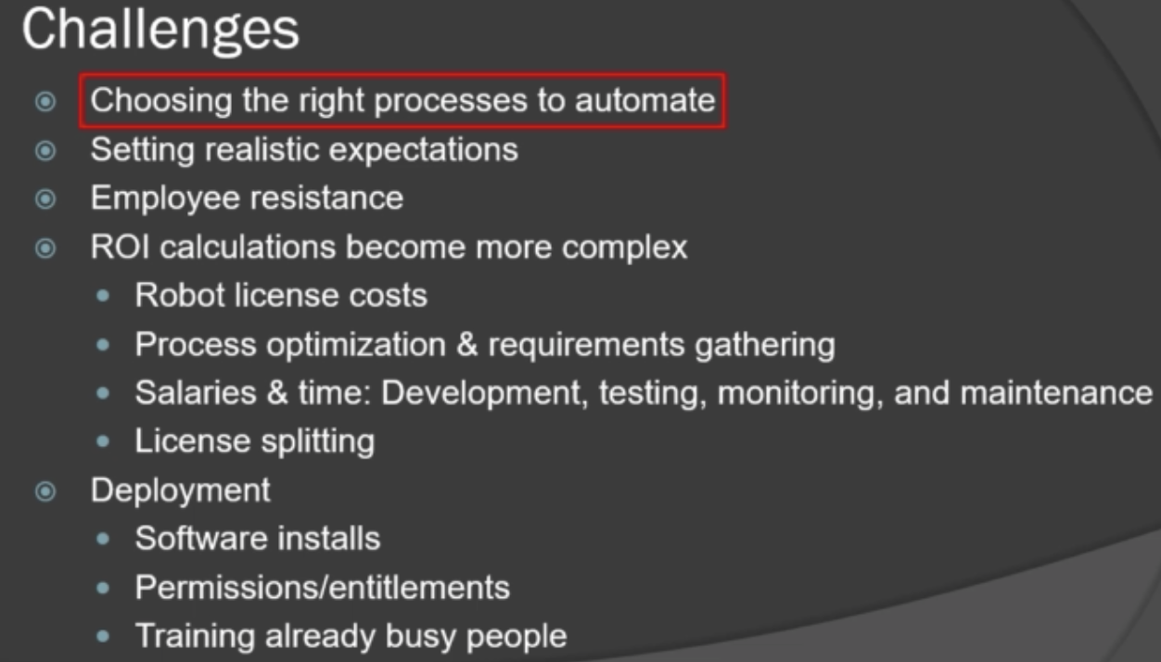

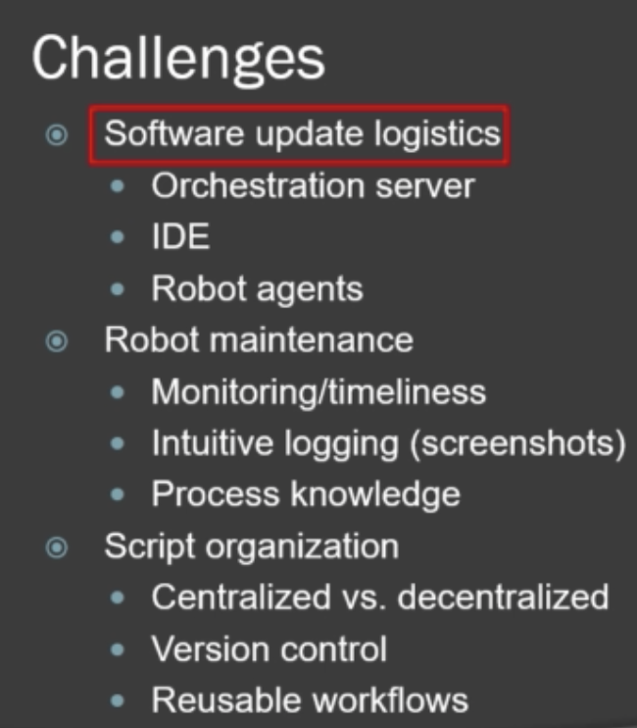

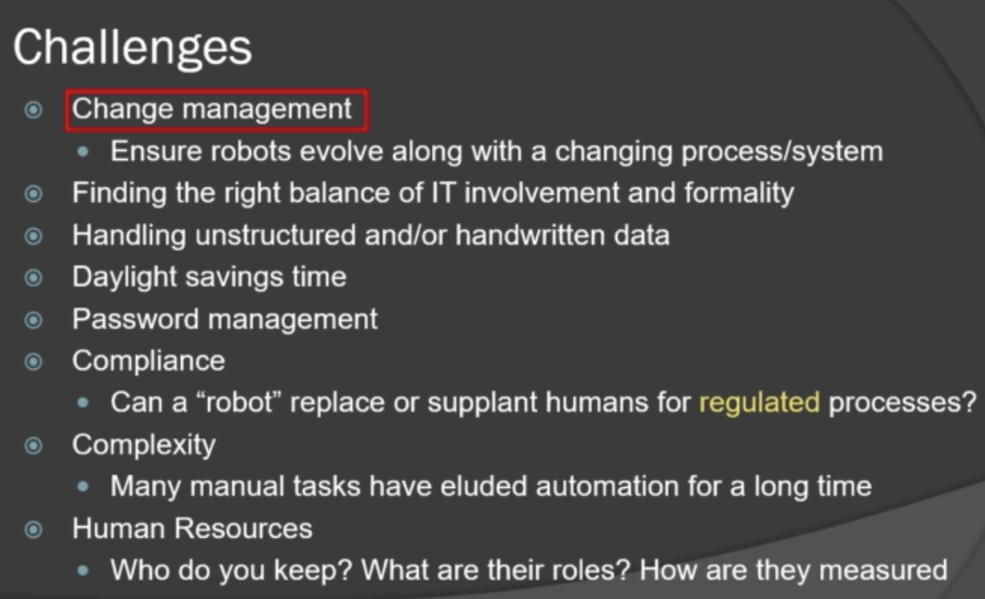

Daylight savings: different schedules of resources

Compliance: any legal issues?

Risks:

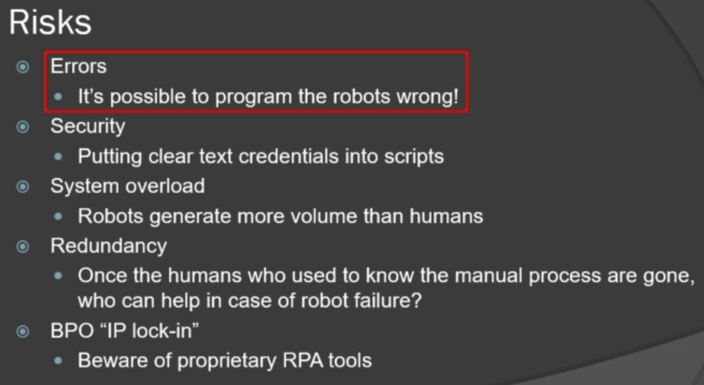

* Automation maturity levels

Most practice stays in Stage 1-2

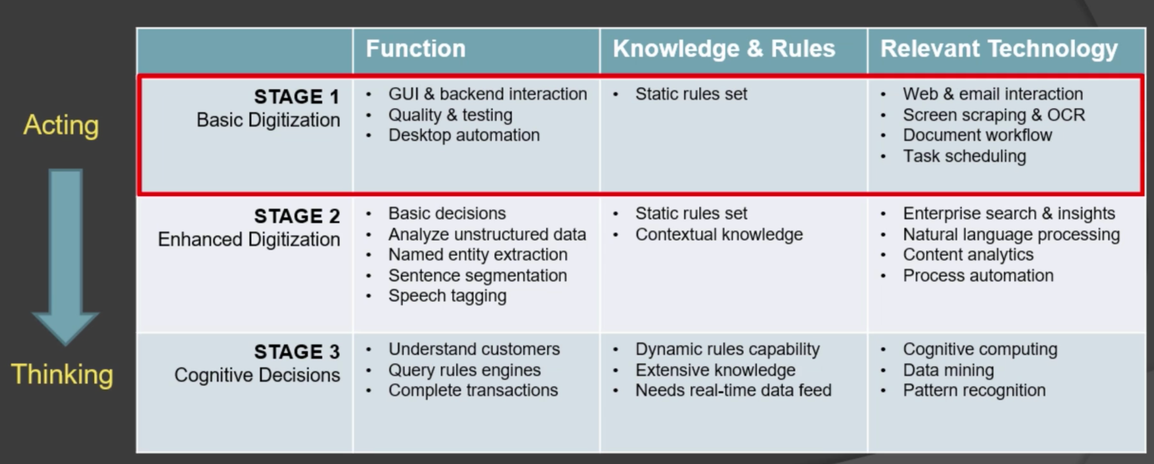

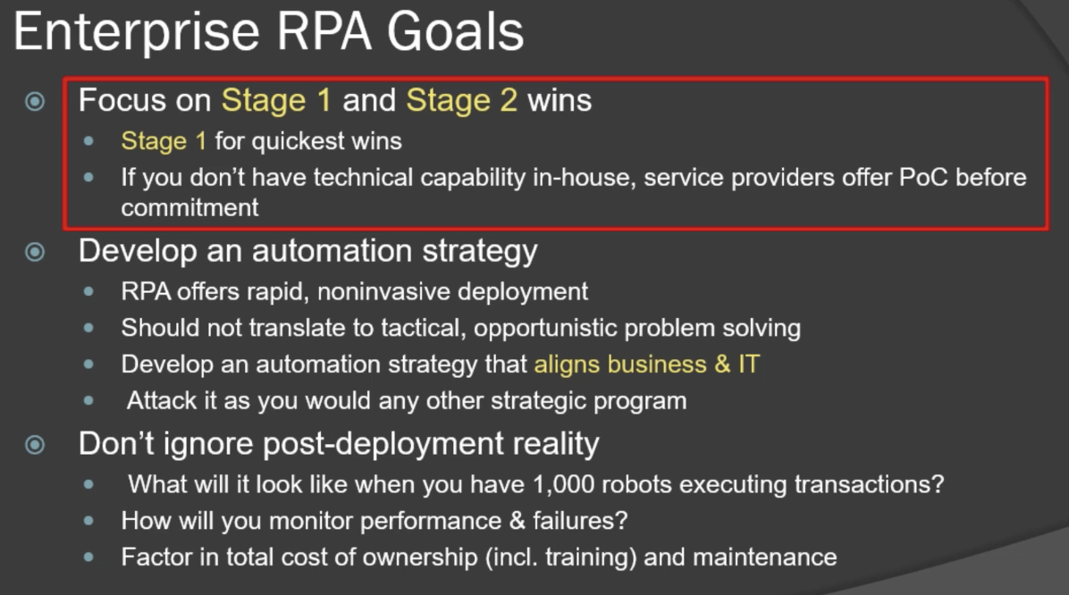

A sample automation journey: GUI -> data analysis -> judgment -> workforce strategies

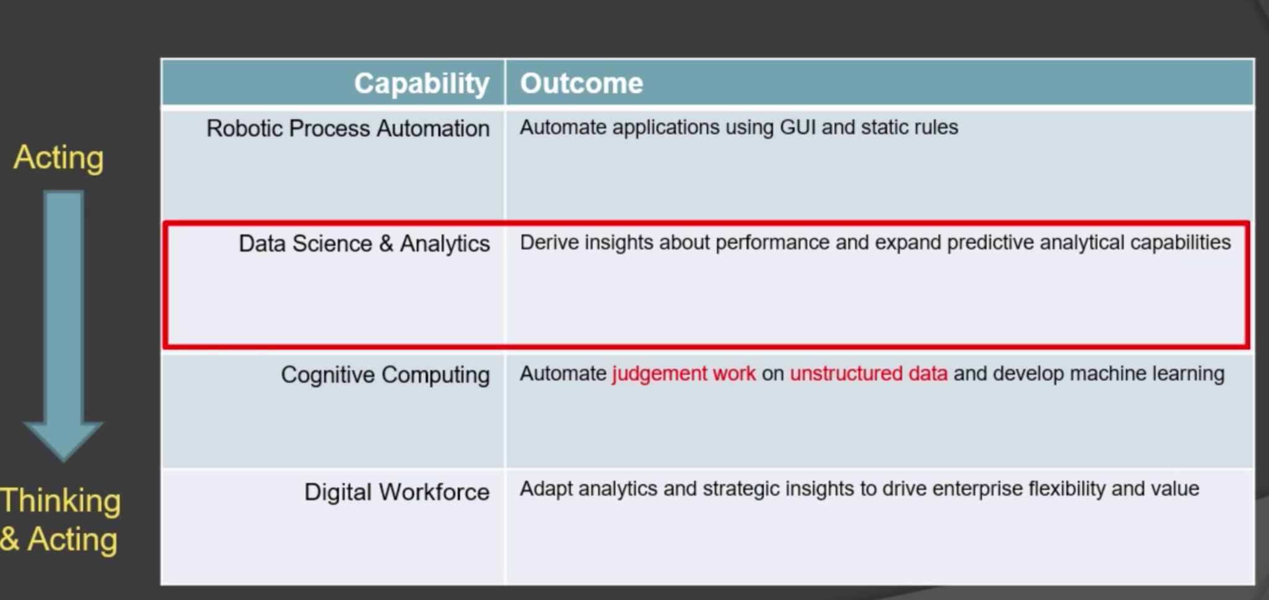

* Growth rate and potential
* Current RPA tools

Features of good tools

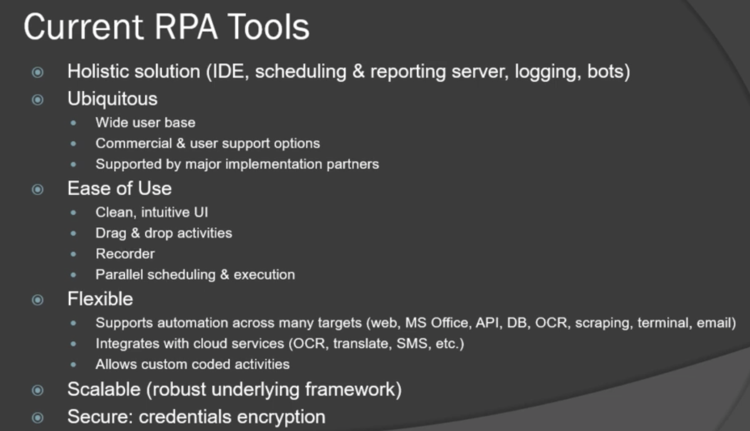

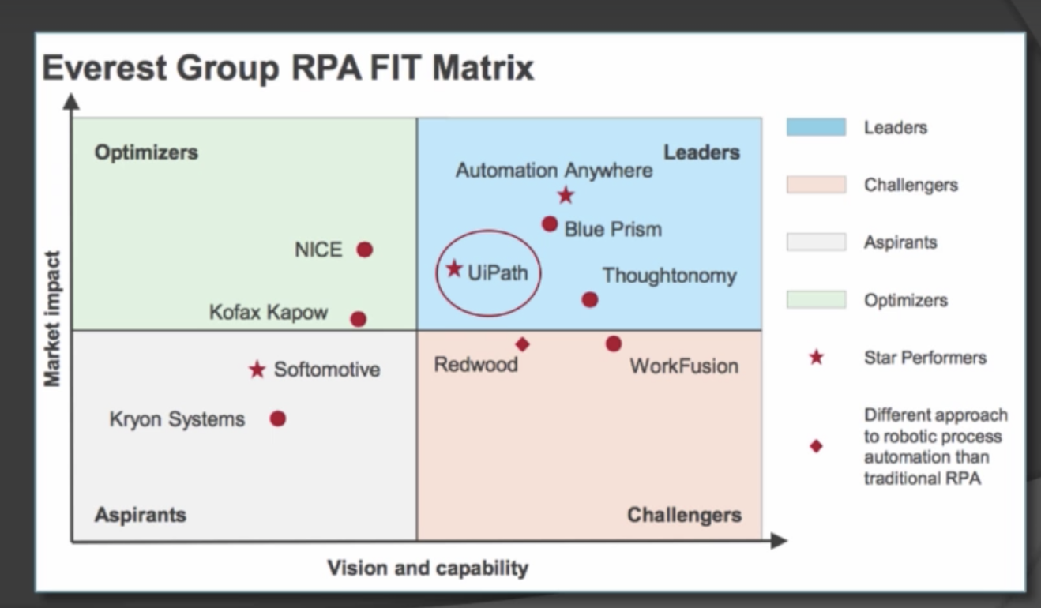

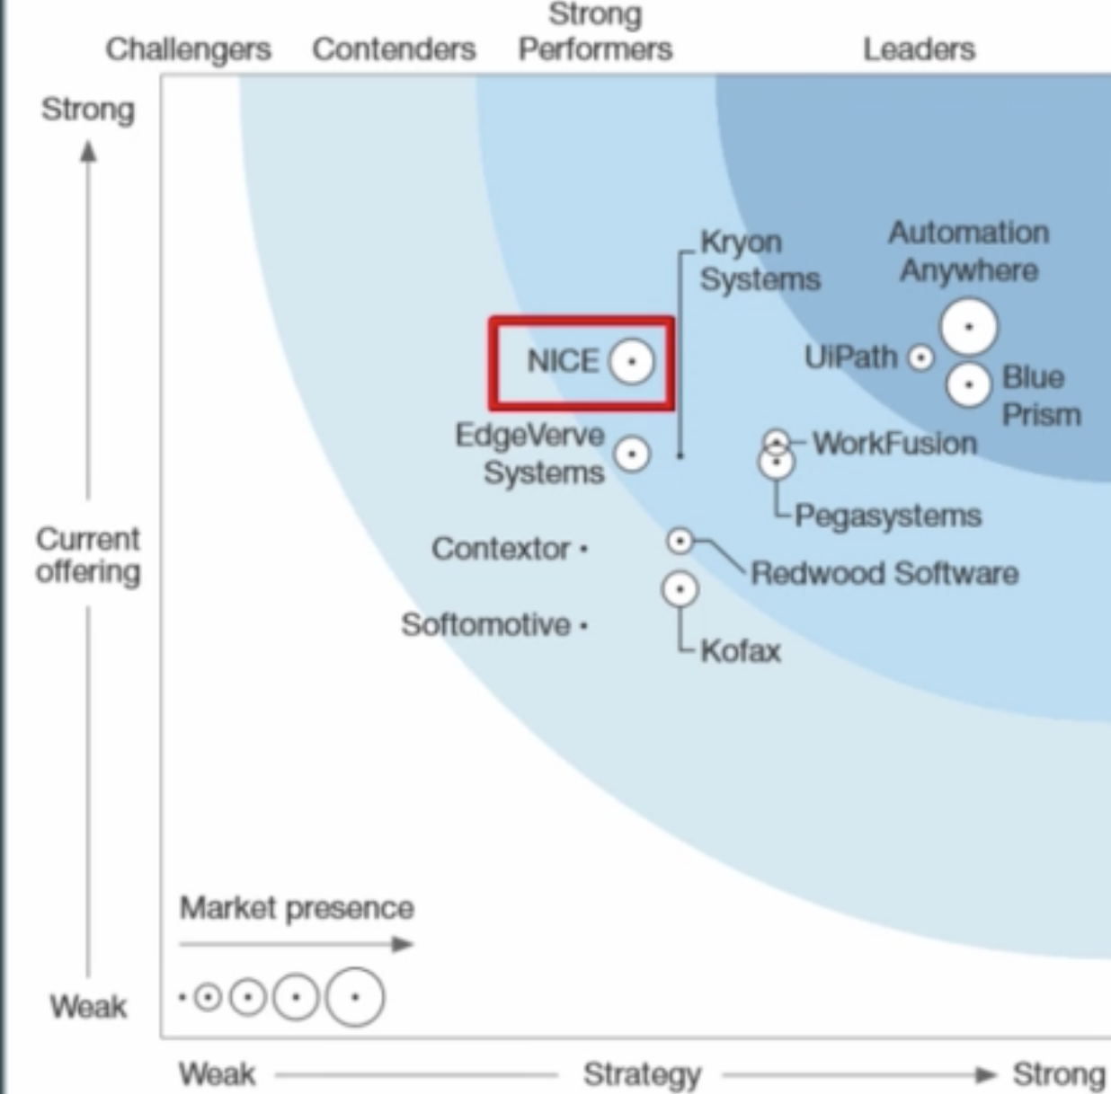

* RPA roles and jobs

Leaderships

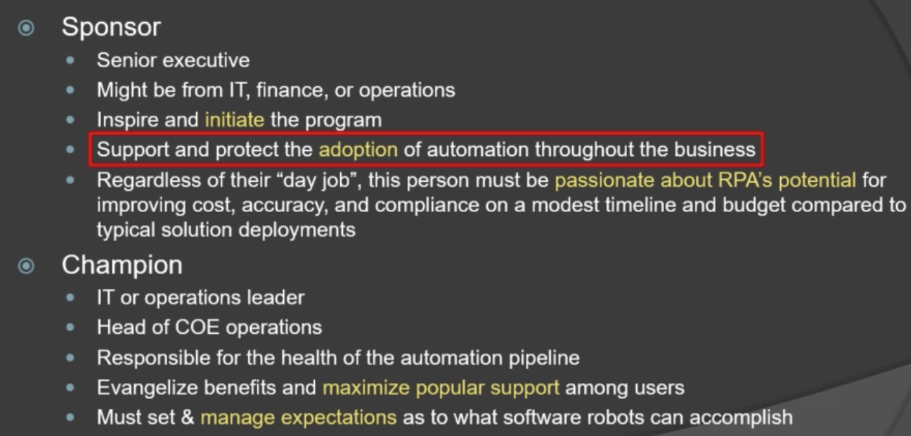

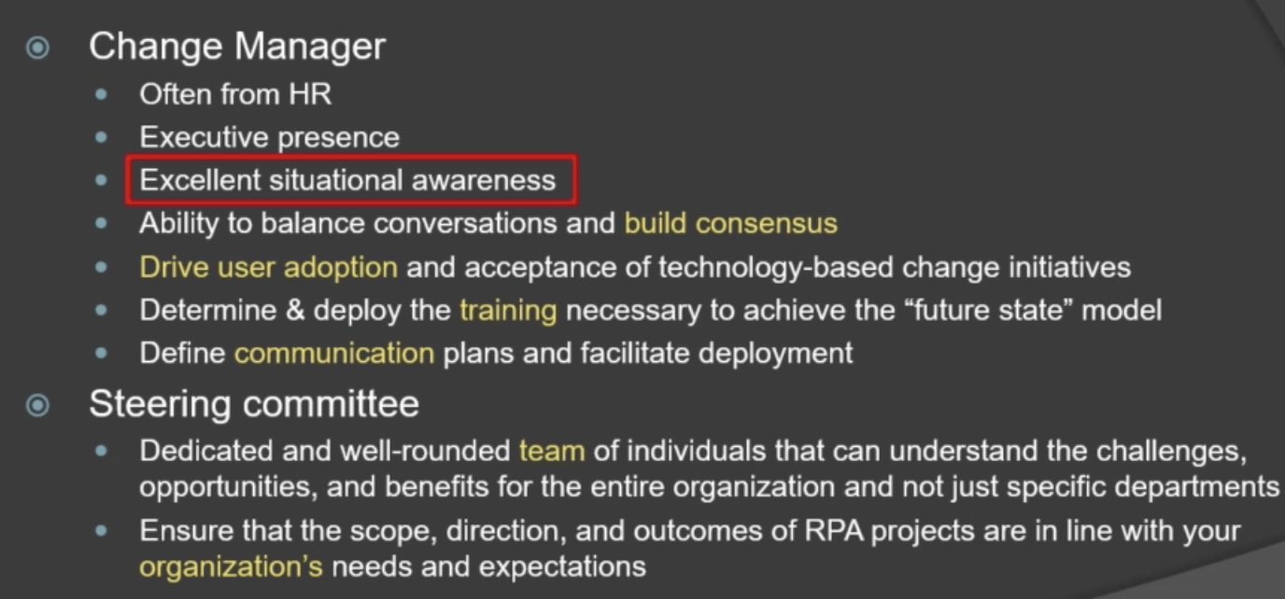

Robotic developers

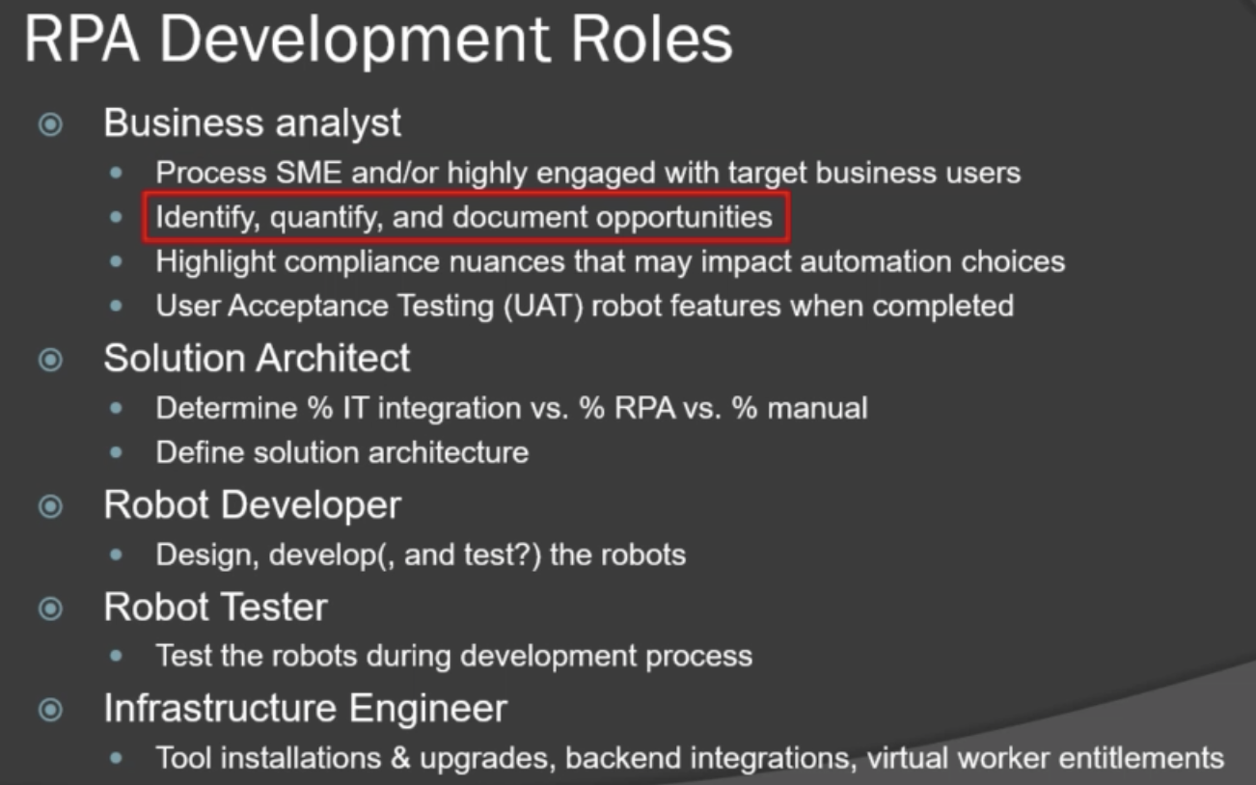

Operations:

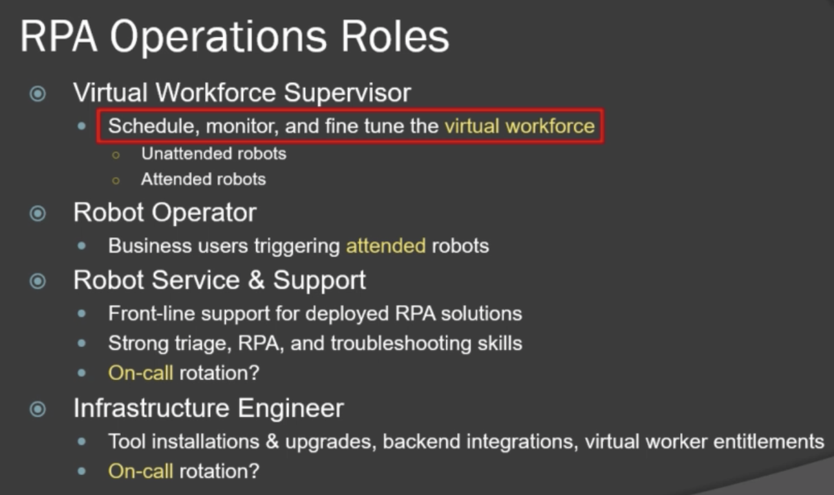

RPA jobs:

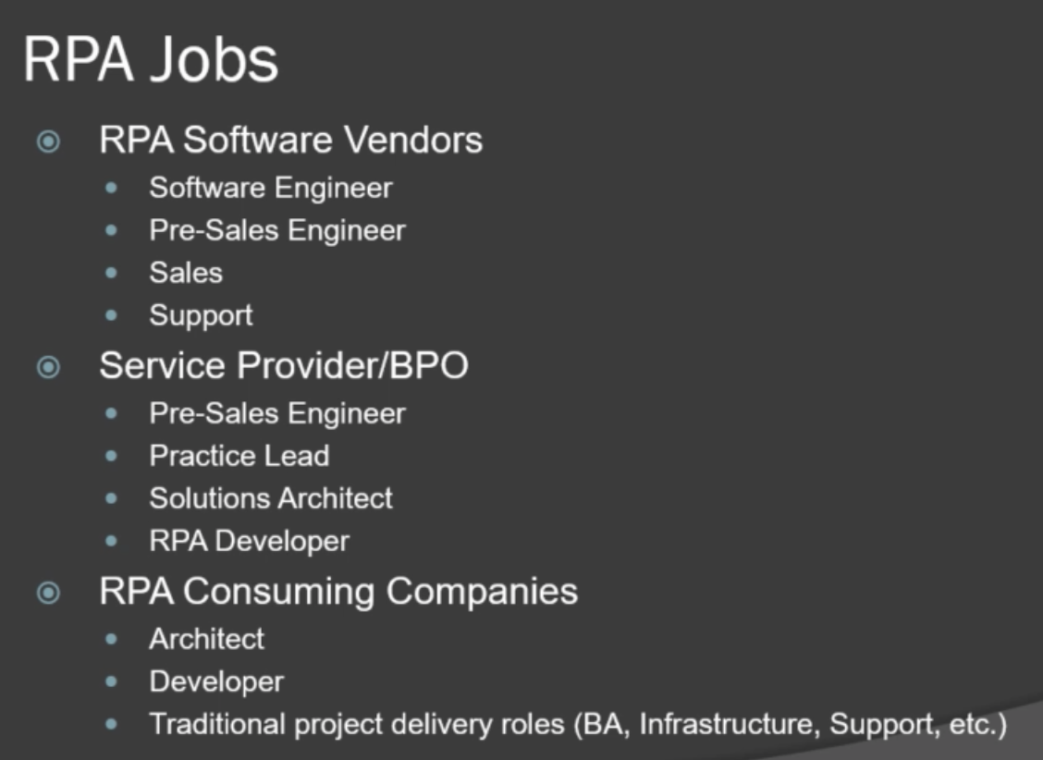

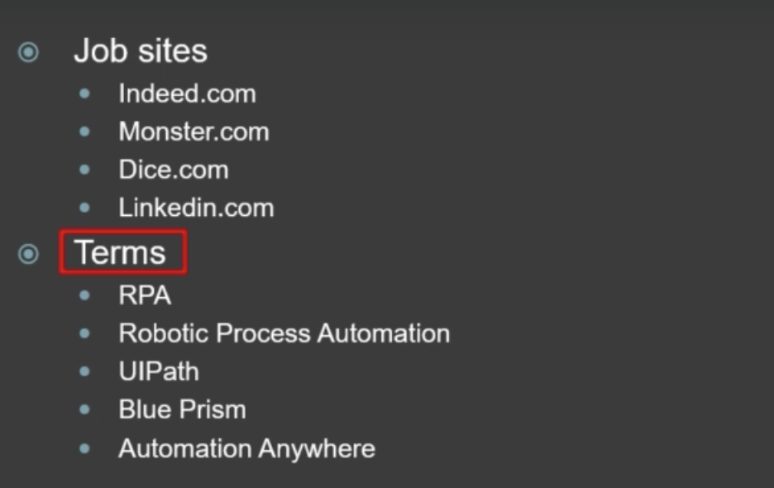

Implementing RPAs in your enterprise

* How to choose the best automation process candidates
* Some standards:
* repetitive /predictable
* Rule-based (no human interpretation required)
* Structured data
* Mid-high volume
* Volume peaks & troughs
* Can be processed inside & outside normal operating hours
* Prone to human errors
* Involve duplicate data on multiple systems
* Not the subject of ongoing optimization
* Quick win

Selection process:

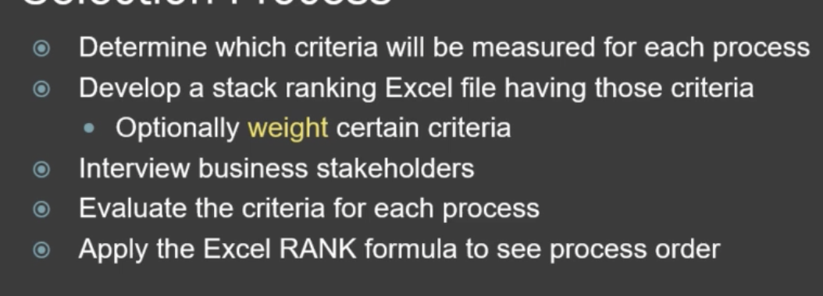

An example of ranking:

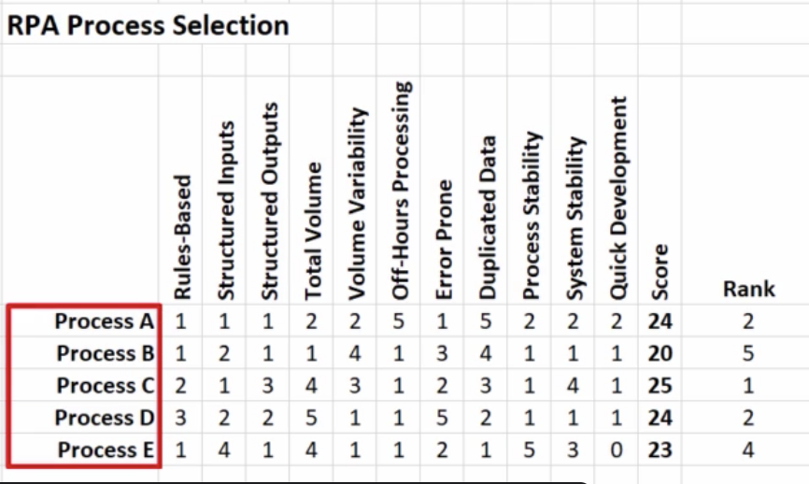

**ROI: building the business case**

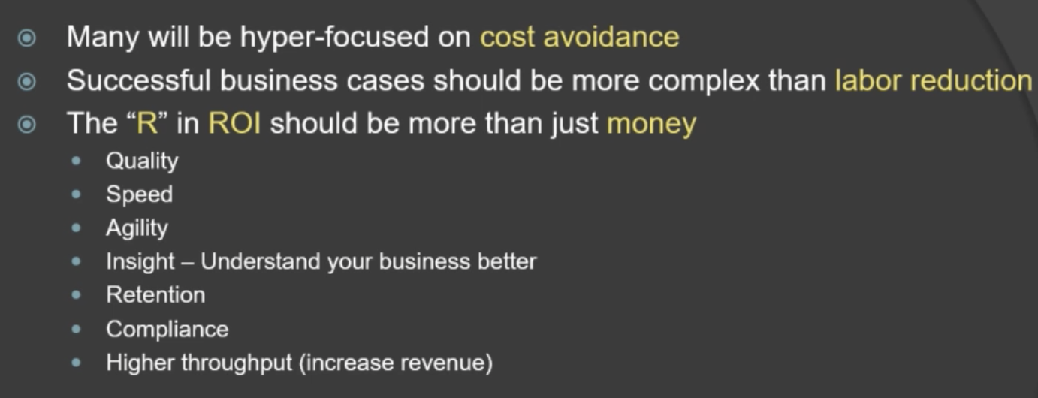

Example:

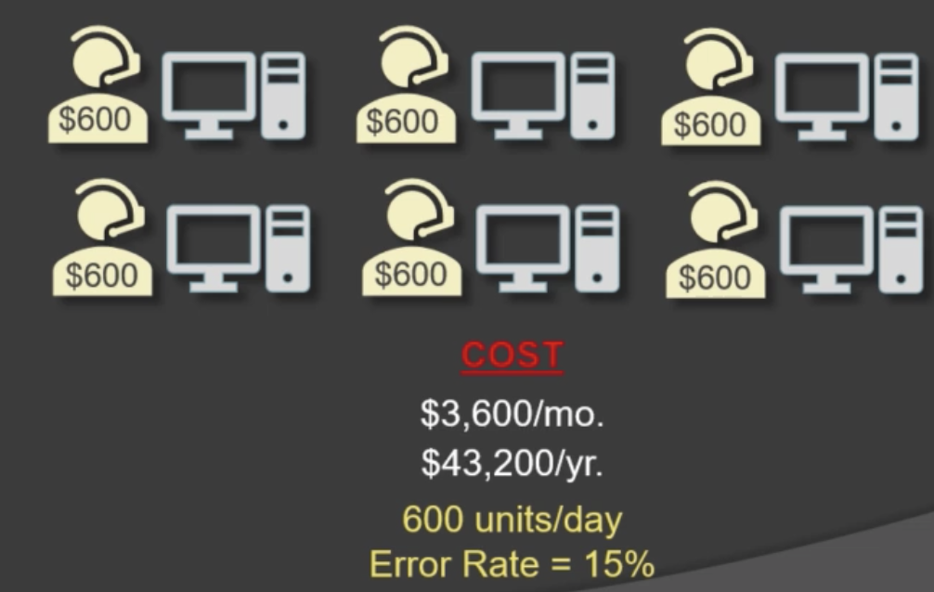

Design different paths:

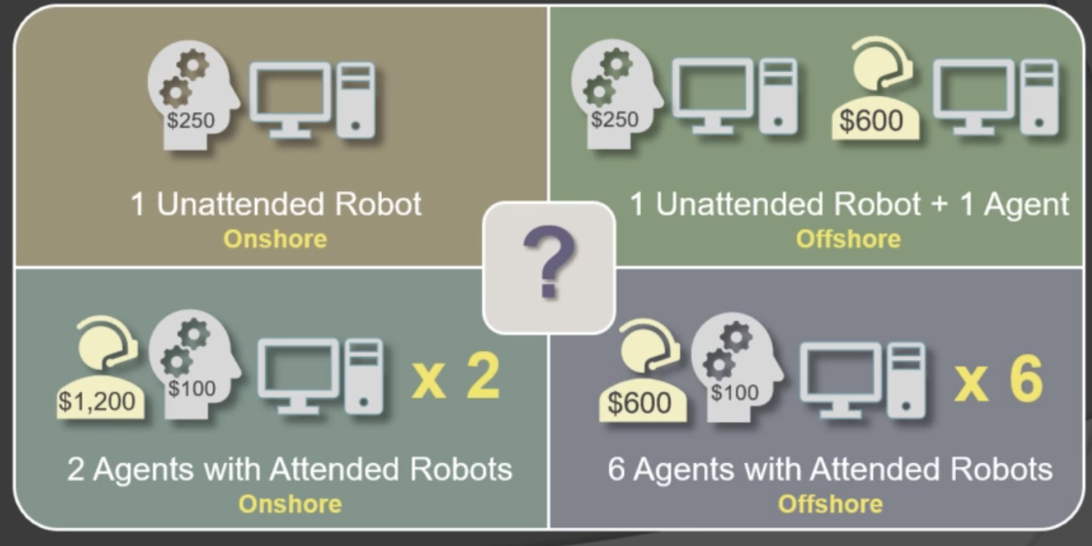

Path A -> save some money, decrease a lot of errors, and have a faster speed

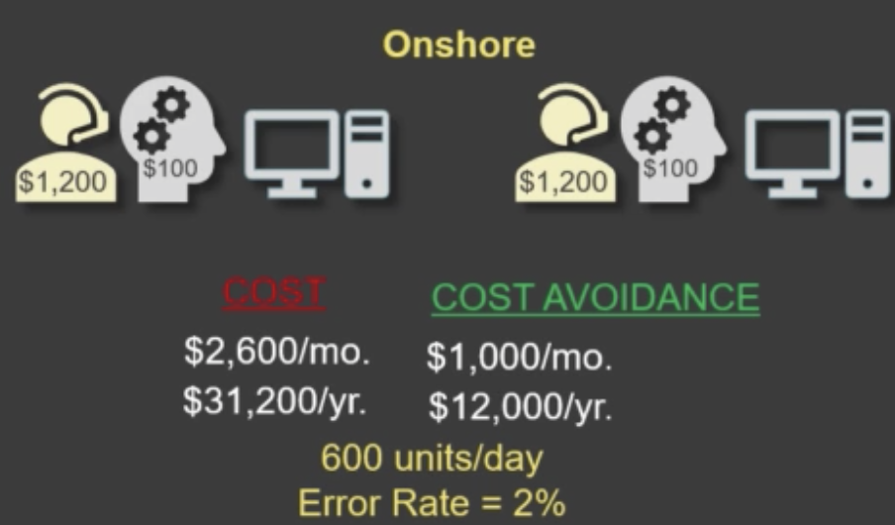

True cost: maintenance also has a fee

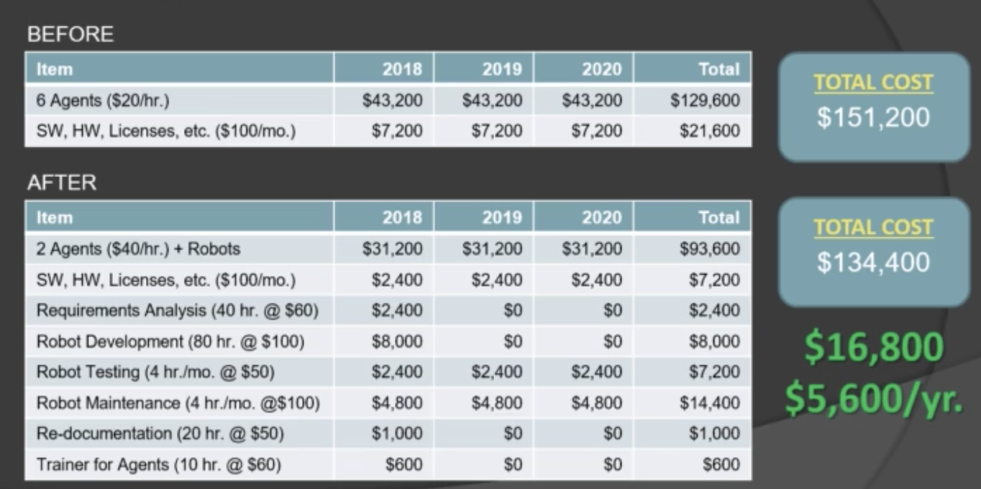

Path B:

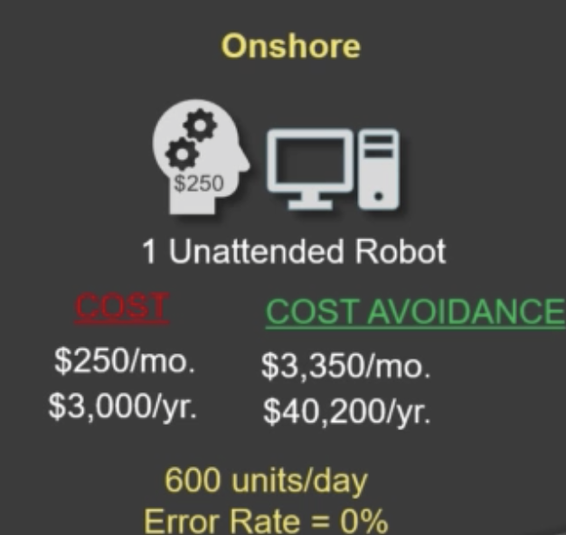

Imagined cost

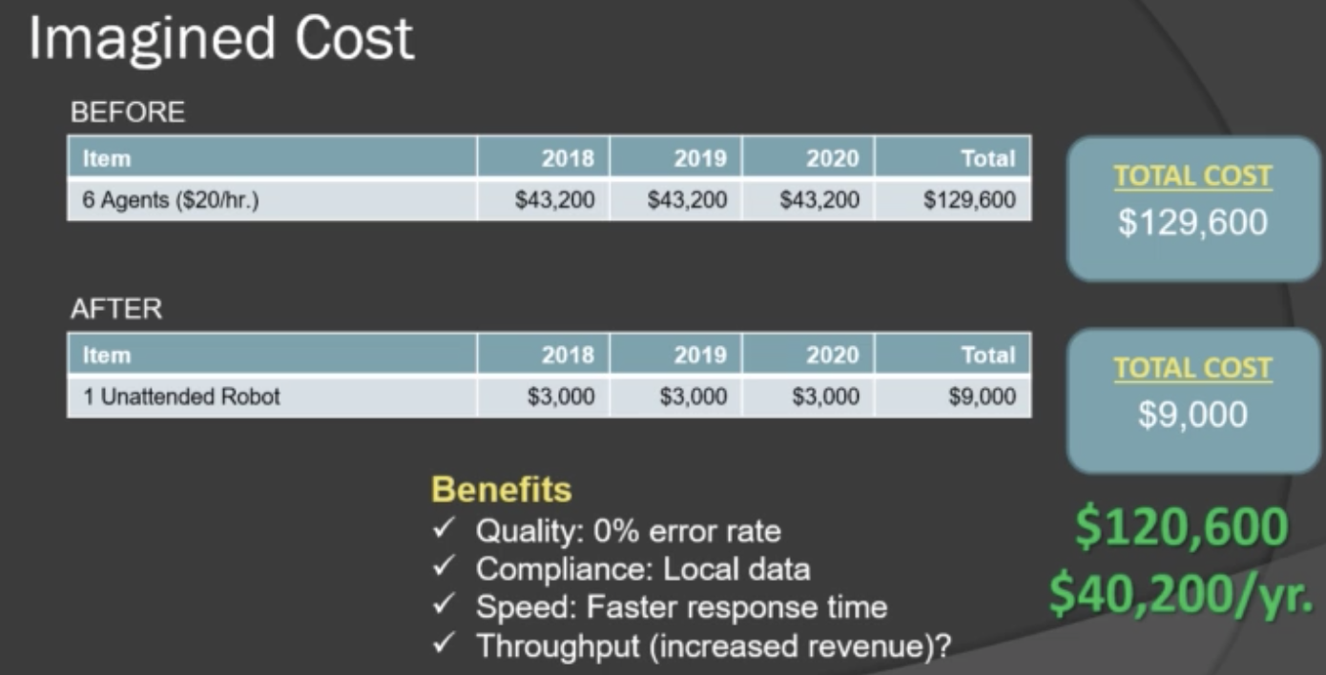

True cost:

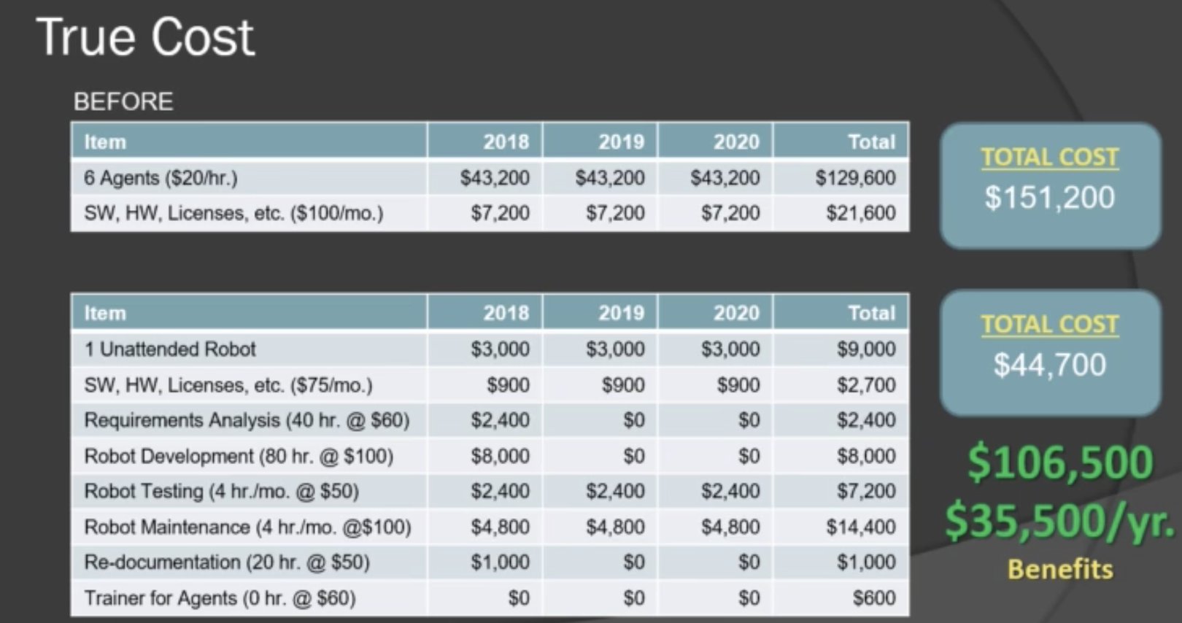

Again, there are many factors other than revenue, such as quality, speed, agility, insights, retention, and compliance; don’t overlook operating expenses of robots

* Proof of concepts

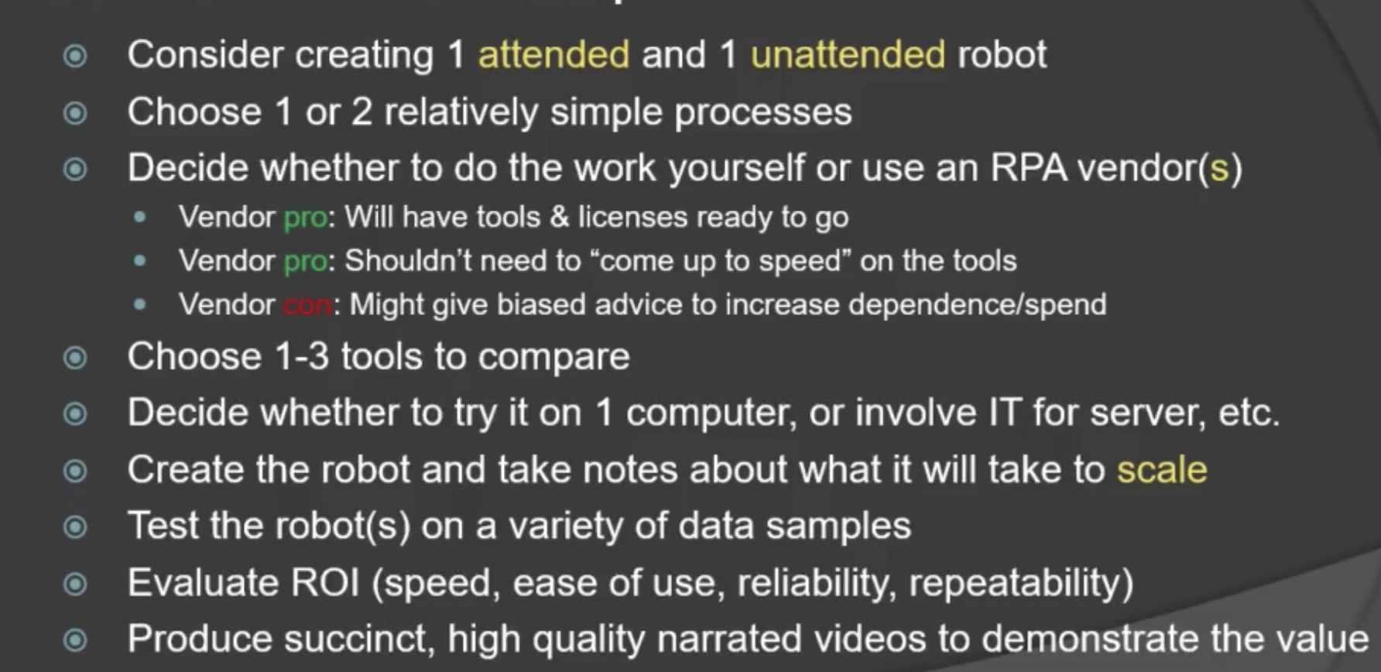

* Center of excellence

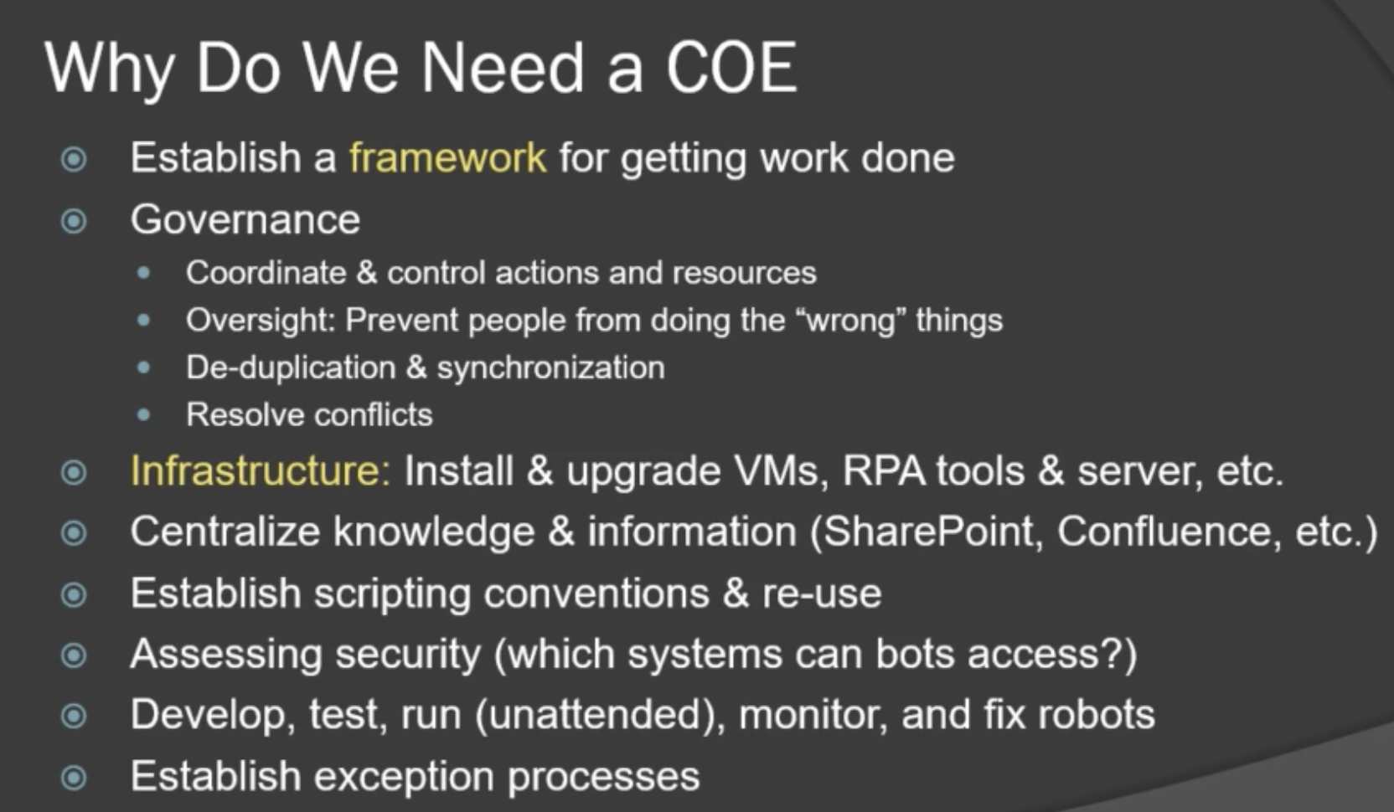

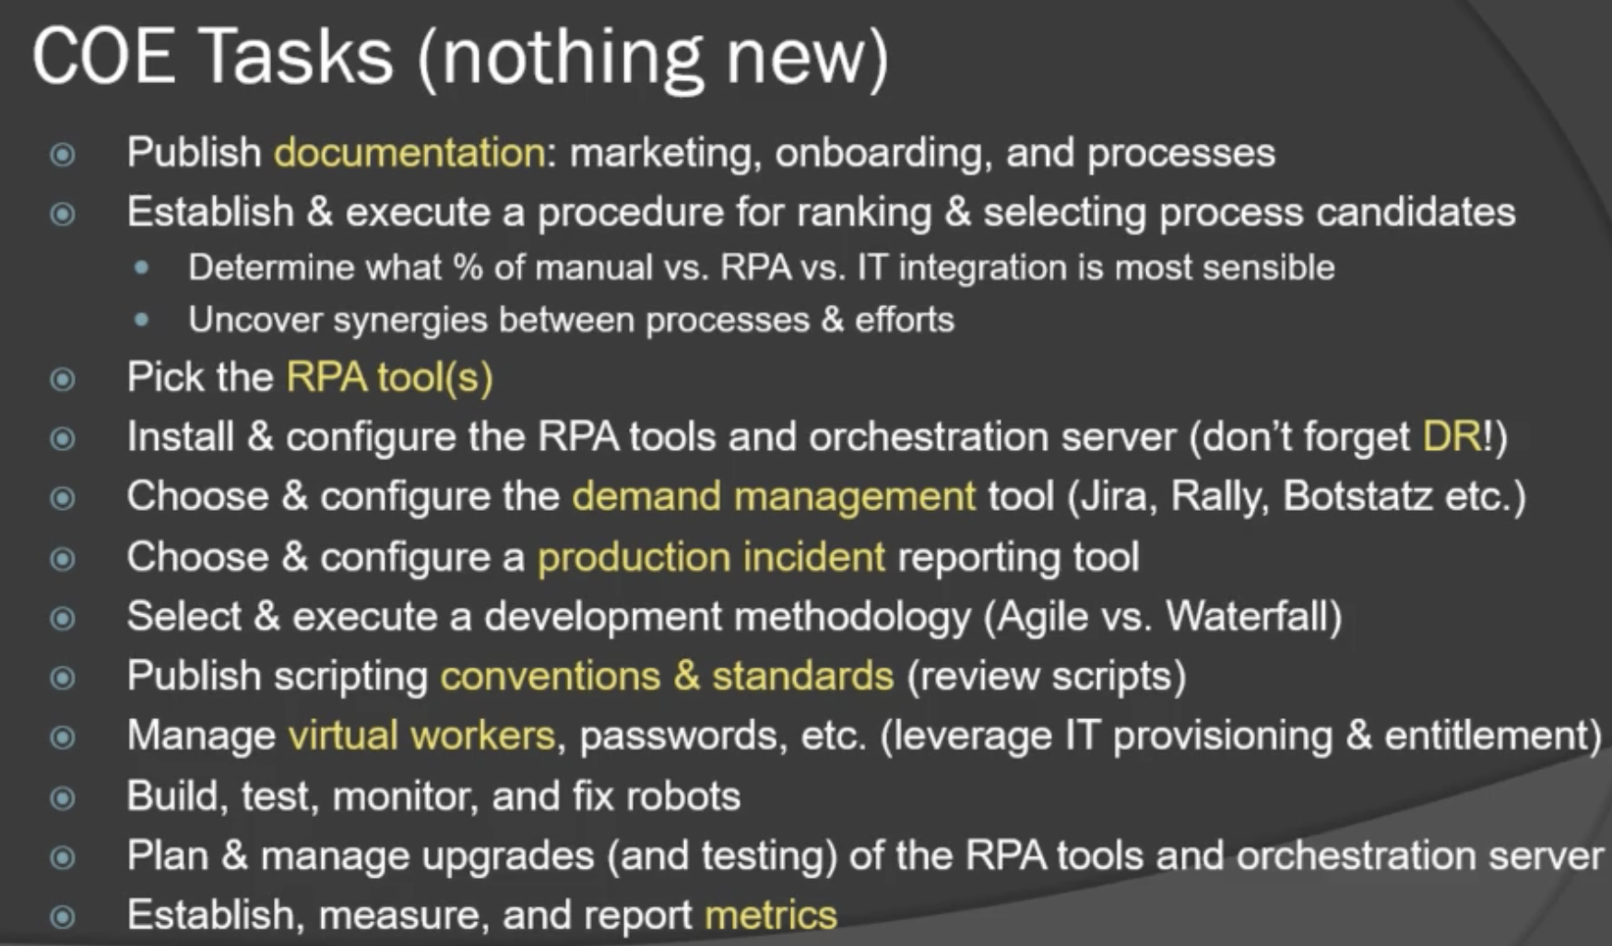

DR: damage recovery

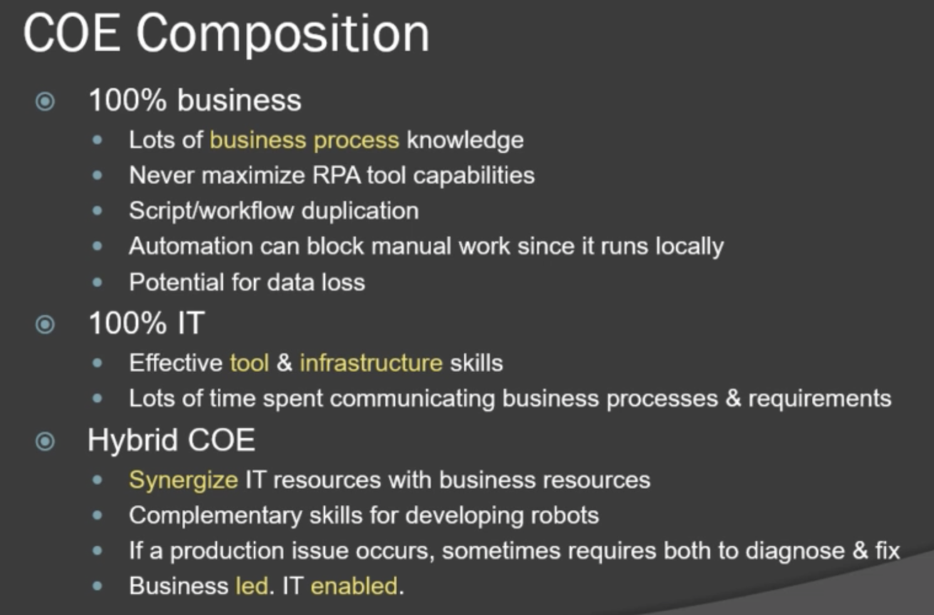

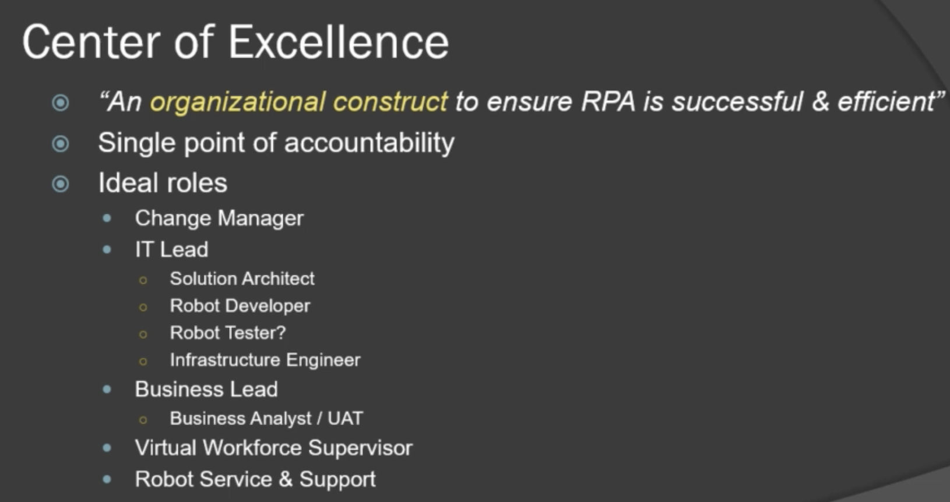

* Summary

